UbisLabel & UnderscoreEncoding:
a new Approach for Label-Encoding in the Multilingual World Wide Web
Dominikus Heckmann
German Research Center for Artificial Intelligence
Dominikus.Heckmann@dfki.de, Saarbrücken, Germany

Matthias Loskyll
German Research Center for Artificial Intelligence
Matthias.Loskyll@dfki.de, Saarbrücken, Germany
ABSTRACT
Internationalization of identification names, for cities for instance, bears two major problems: which language to choose for the label and which character set to choose for those characters that are not covered by the ASCII character set. UbisLabel is a new approach to combine ideas for internationalizing the labels for identifiers on the Semantic Web and the Web in general. We introduce an inline syntax to put several, possibly multilingual labels into one string. UderscoreEncoding is able to represent the full Unicode code points shorter than existing textual UTF representations. It has been developed in order to represent special characters in an efficient manner without using any characters apart from alphanumerical letters plus the underscore only. The idea is that such encoded labels can be attached directly to the identifiers (like URIs) without the need to be further encoded elsewhere in the Internet.
KEYWORDS
Label, Multilingual, Unicode, Encoding, Semantic Web, UTF
- INTRODUCTION
What are quality dimensions of identifiers? And what are quality dimensions of labels? One could be (1) readability for humans: can the identifier and the label be remembered, or easily explained? Another one could be (2) stability: does the name stay the same if the resource is moved, is it changing or permanent? (3) efficiency: where are the used characters allowed? Do they need to be encoded if the identifier has to be stored in a database, in an RDF document, in OWL, or in an URI string? Another quality of identifiers (4) informativeness: is there any other information encoded in the identifier like for example the date, the group, the label, the owner or the creator? In this paper we look at a new syntax to define permanent, multilingual labels that allow to be used in informative and readable identifiers. This paper is divided into two major parts. The first one deals with labeling and the second one with encoding.
- UbisLabel Handling International Labels
UbisLabel is a new approach to combine several ideas for internationalizing the labels in identifiers for semantic web and the Web in general. UbisLabel should not only be used in ordinary text form, but in names that are used to denote concepts in ontologies.
The term Web 3.0 is used here in the way defined as rule of thumb in [Wahlster and Dengel 2006] as Web 3.0 = Semantic Web + Web 2.0. In this Semantic Web setting we have to cope with classes, instances, relations and properties that need to be identified and named in a distributed fashion by a whole community of authors, probably spread around the world, speaking different languages.
Research on adaptivity mostly concerns applications or whole systems. In this paper we look at the fundamental issue of adaptive labels for concepts that could, for example, be applied to Semantic Web and international Web 2.0 applications.
2.1 Motivation for UbisLabel
UbisLabel are supposed to support names that are used to denote concepts in ontologies. In general it
is better to use only ASCII characters in names, even if selected special chars are allowed.

The city of Prague: which should be the label of the concept for the capital in the Czech Republic for a German user? The German name is Prag; the English name is Prague; while the original
Czech name is Praha.

The city of Munich: which should the label of the concept for the capital of Bavaria be for a Czech user? The German name is München; however, the city is often spelled Muenchen since the usage of the non-ASCII character ’ü’ could lead to problems; the English name is Munich.

The city of Tokyo: which should the label of the concept for the capital of Japan be for a Japanese user currently visiting Germany? The Japanese name is ; the English name is Tokyo; while the German name is Tokio.

Internationalization of identification names, for cities for instance, bears two major problems: which language to choose and which character set to choose for those characters that are not covered by the ASCII character set. The answer to the fist issue could be: the user’s mother language, an interlingua like English, or the language of the country where the city is located. However, in the city of Brussels, for instance, several languages are official languages at the same time which leads to Bruxelles in French and Brussel in Flamish. A flexible but still lightweight solution is needed for denoting concepts internationally. Google, for example, mostly presents the local names in its geo-services like Google Earth and Google Maps, which leads to the problem for European users to read Asian maps and vice versa, even though Google supports alternative labels and names for searching. To summarize the idea behind the UbisLabel approach: it enables multiple labels for any concept from the knowledge representation point of view and furthermore it allows the adaptive selection and presentation of a label according to a situation-aware strategy. The UbisLabel approach is tested in the parallel UbisWorld project[1] with the three languages German (DE), English (EN) and Japanese (JP). The issue to identify each existing language uniquely has been solved by the ISO 639 Language Codes standard[2]. Note that ISO 639-2 is the alpha-3 code and ISO 639-1 is the alpha-2 code. If multiple codes for the same language are provided, they are considered synonyms.

2.2 UbisToken, UbisPrefix
UbisToken and UbisPrefix are defined and used in the later UbisLabel Syntax.

[D] UbisToken ::= ((Digit | Letter | UChar) | ("-" (Digit | Letter | UChar)))*
[D] UbisPrefix ::= Upper ((Digit | Upper) | ("-" (Digit | Upper)))*

What makes these rules a bit complex is the circumstance that no double-hyphen is allowed. An UbisPrefix is a restricted UbisToken that starts with an upper case letter and that does not contain any lower case letters or any UChars. A UbisPrefix consists only of upper case letters, digits and hyphens, while it always starts with an upper case letter. However, for compatibility with HTML/XML comments (<!- - comment - - >), the string ”- -” (double-hyphen) must not occur within a UbisPrefix or UbisIdentifier.

2.3 UbisLabel Syntax
[D] UbisLabel ::= SimpleLabel | LanguageLabel | MultiLabel
[D] SimpleLabel ::= UbisToken
[D] LanguageLabel ::= (LanguageCode)+ ".." UbisToken
[D] MultiLabel ::= UbisLabel ("..." UbisLabel)+
[D] LanguageCode ::= ISO_639_1 | "ME"
[D] ISO_639_1 ::= "EN" | "DE" | "JP" | "YI" | "ZH" | ...

Three kinds of UbisLabel are supported: SimpleLabel that can be understood as normal strings with no further structure, LanguageLabel that also express in which language they are written, and finally the MultiLabel. They allow having a list of labels within one UbisName, which bears the great potential to introduce multilinguality within one string, as discussed above. If needed, later extensions are possible from the used ISO 639-1 Code [3] with two characters to the ISO 639-2 Code with three characters or to the RFC 3066 [4] that is used in XML to denote languages. The possibility to write several language codes in a row without any operator in between can be seen as syntactic sugar. This is possible because parsing the string is straight forward due to the fixed length of two characters each. The idea behind that is to provide a shortcut-option for the case when a named entity carries the same label over different languages. The UbisName normal form, however, assumes only one language code per basic label. The new language code "ME" can be used for non-common nicknames that are only known to the user. The order of the labels play the following role: the first label to the left is used as default if no language is selected.

[E] Munich
[E] EN..Munich
[E] EN..Munich...FR..Munich...DE..M_AA0nchen
[E] CITY..2867707.ENFR..Munich...DE..M_AA0nchen
[E] CITY..2988507.ENFRDE..Paris

- UnderscoreEncoding: Handling Unicode Characters

Character encoding standards define the identity of every existing character world-wide together with its numeric value, the so called code point. A complete description of all officially existing, highly developed Unicode standards can be found at [www.unicode.org]. In the UbisName project, reasonably short string representations of all Unicode code points are needed in order to represent international names within URIs. Since we were not satisfied with the widely spread UTF-8 percent-encoding for
URIs, we developed UbisUTF together with the UnderscoreEncoding with the focus on optimizing the length of an encoded string. The result is remarkable. Most of the single Unicode code point representation in UbisUTF is up to 75% shorter or at least equally long than the ones in UTF-8, UTF- 16 and UTF-32. The main idea behind UbisUTF is to encode the code points in Base62 numbers. UbisUTF has been designed in such a way that the Unicode characters corresponding to the familiar ASCII set have the same byte values as ASCII. This is realized by leaving the first 128 code points unchanged in Base16. All other characters are defined in Base62 which uses all 10 digits and 52 letters of the English alphabet.

3.1 The Unicode Standard 5.0
Unicode provides a unique number for every character, no matter what the platform is, no matter what the program is, no matter what the language is [Unicode.org]. Fundamentally, computers just deal with numbers. They store digits, letters and other characters by assigning a number for each one. Before Unicode was invented, there were hundreds of different encoding systems for assigning these numbers, such that data often runs the risk of corruption, if no clear statement about the character encoding is given.
The Unicode Standard defines three encoding forms that allow the same data to be transmitted in a byte, word or double-word oriented format (i.e. in 8, 16 or 32-bits per code unit). All three encoding forms encode the same common character repertoire and can be efficiently transformed into one another without loss of data. According to [www.unicode.org], UTF-8 is popular for HTML, XML and similar protocols. UTF- 8 is a way of transforming all Unicode characters into a variable length encoding of bytes. It has the advantage that the Unicode characters corresponding to the familiar ASCII set have the same byte values as ASCII. UTF-16 is popular in many environments that need to balance efficient access to characters with economical use of storage. It is reasonably compact and all the heavily used characters fit into a single 16-bit code unit, while all other characters are accessible via pairs of 16-bit code units. UTF-32 is popular where memory space is no concern, but fixed width, single code unit access to characters is desired. Each Unicode character is encoded in a single 32-bit code unit when using UTF-32. All three encoding forms need at most 4 bytes (or 32-bits) of data for each character. Many existing systems don’t support the whole Unicode character set. Instead they apply the Basic Multilingual Plane. A basic multilingual plane code point is a Unicode code point between U+0000 and U+FFFF. In the UbisName project however we decided to implement the full range of Unicode code points which is U+0000 to U+D7FF and U+E000 to U+10FFFF. Since in an XML environment a few Unicode code points are not allowed, we also disallow these in the UbisName approach and come to the set of defined Unicode code points:

[0] UnicodeCodePoint ::= #x9 | #xA | #xD | [#x20-#xFF]
[#x100-#xD7FF] | [#xE000-#xFFFD] |
[#x10000-#x10FFFF]

Figure 1: Unicode Encoding Forms for four selected code points, according to [www.unicode.de] in the hexadecimal alphabet

Unicode notation: U+004D U+00FC U+006E U+0063 U+0068 U+0065 U+006E
Decimal code points: 77 252 110 99 104 101 110
Decimal NCRs: &#77;&#252;&#110;&#99;&#104;&#101;&#110;
Hexadecimal codes: 4D FC 6E 63 68 65 6E
Hexadecimal NCRs: &#x4D;&#xFC;&#x6E;&#x63;&#x68;&#x65;&#x6E;
UTF-8 code units: 4D C3 BC 6E 63 68 65 6E
UTF-16 code units: 004D 00FC 006E 0063 0068 0065 006E
JavaScript escapes: M\u00FCnchen (based on UTF-16)
Percent encoding: M%C3%BCnchen (based on UTF-8)

Figure 2: Different existing Unicode encodings for the string München, calculated with Ishida utilities, Unicode Code Converter v6: http://people.w3.org/rishida/scripts/uniview/conversion.php

3.2 From Unicode code points to UbisCode
UTF-Ubis is a new Unicode Transformation Format that maps to each Unicode code point a corresponding UbisCode in Base62 notation. The formal grammar is given in this specification using a simple Extended Backus-Naur Form (EBNF) notation as defined in [XML-Spec, 2006]

3.2.1 Digits, Letters and Alphabets
The following character sets describe the numerical alphabets for the decimal Base10 system, the hexadecimal Base16 system[5], the Base62 system as well as the Base64 system[6].

[0] Digit ::= "0" | "1" | "2" | "3" | "4" | "5" | "6" | "7" | "8" | "9"
[1] Base8 ::= "0" | "1" | "2" | "3" | "4" | "5" | "6" | "7"
[2] Upper ::= "A" | "B" | "C" | "D" | "E" | "F" | "G" | "H" |
"I" | "J" | "K" | "L" | "M" | "N" | "O" | "P" |
"Q" | "R" | "S" | "T" | "U" | "V" | "W" | "X" |"Y" | "Z"
[3] Lower ::= "a" | "b" | "c" | "d" | "e" | "f" | "g" | "h" |
"i" | "j" | "k" | "l" | "m" | "n" | "o" | "p" |
"q" | "r" | "s" | "t" | "u" | "v" | "w" | "x" |"y" | "z"
[23] Letter ::= Upper | Lower
[4] Base10 ::= Digit
[5] Base16 ::= Digit | "A" | "B" | "C" | "D" | "E" | "F"
[6] Base62 ::= Digit | Letter
[7] Base64 ::= Digit | Letter | "-" | "_"

The semantics for the upper case letter "A" is the decimal number (16)₁₀. The semantics for the upper case letter "B" is the decimal number (17)10. This row is continued up to the lowercase letter "z" that represents the decimal number (61)₁₀.We have chosen Base62 since in most situations where string representations are needed, like in URIs or in NameTokens, the digits and the letters are characters that can be used directly without additional meaning and without any additional encoding.

3.2.2 UbisCode
The UbisCode defines new code numbers for Unicode code points and represents them in Base62. These new codes are represented as sequences of either two, three or four characters. They are called TwoPoint, ThreePoint and FourPoint respectively. An important, chosen property is that the TwoPoint starts with a digit (0-7), the ThreePoint with an upper case letter, and the FourPoint with a lower case letter.

[8] UbisCode ::= TwoPoint | ThreePoint | FourPoint
[9] TwoPoint ::= Base8 Base16
[10] ThreePoint ::= Upper Base62 Base62
[11] FourPoint ::= Lower Base62 Base62 Base62

Since the character sets Digit and Lower and Upper are disjoint, the fist character of each UbisCode can be used to define and indicate the number of following characters that belong to the same code point. In a Base62 system, the set of all TwoPoints has a capacity of an 8 x 62 array, with altogether 496 choices. The ThreePoint form a 26 x 62 x 62 cube, with altogether 99944 choices, and the ThreePoint 26x 62³= 6196528.
Figure 3 shows the overview of the distinguished number areas that are mapped to this structure. The Unicode code points are divided into 17 blocks of so called planes, see Figure 3. One plane in Unicode has 0xFFFF = 65536 points. Thus, the ThreePoint can carry all code points of the first plane which is called the basic multilingual plane at once (65536) and represent them with only three characters each. Examples of UbisCode are A2W, G34 and 20.

3.2.3 Conversion from UTF-32
In order to denote numbers in Base62, we introduce in analogy to "0x" for Hexadecimal numerals the new notation "0y" that should be added as prefix to the base62 numeral. Alternatively one could use the notation (X)₆₂.
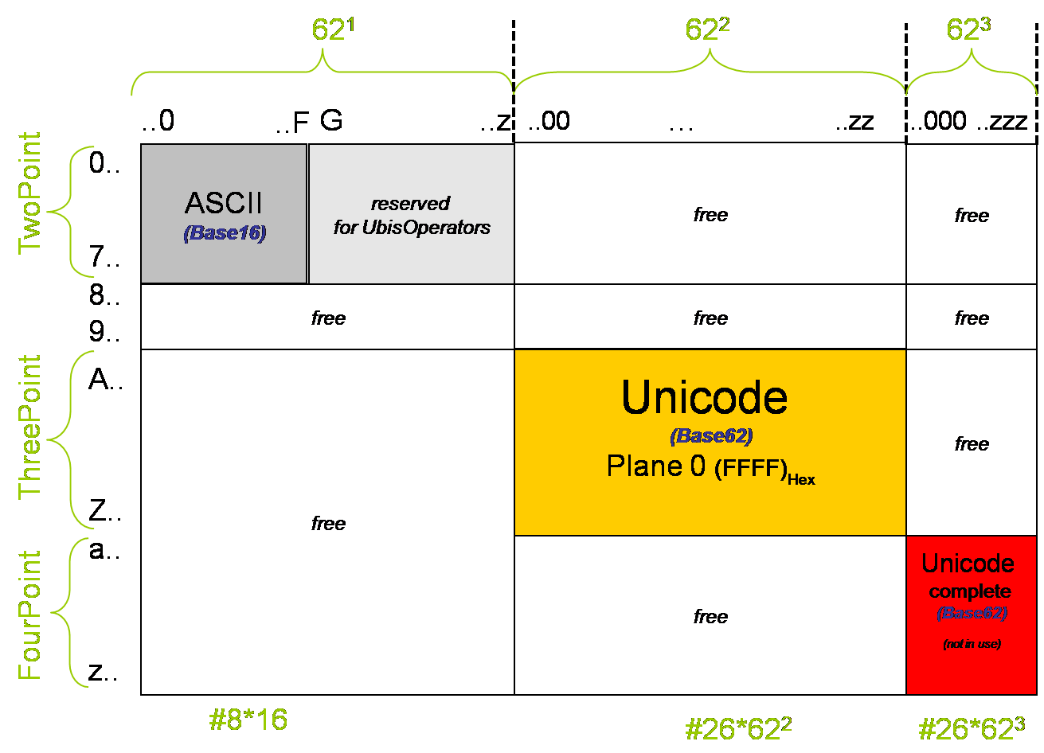
Figure 3: Unicode Encoding UbisUTF: OnePoint TwoPoint ThreePoint

1. TwoPoint: All UbisCode U corresponding to code points P <= 0xFF are unchanged. This means one could work directly with Base16, or one calculates the new value in Base62 with the formula [7]:
U = (P mod 16) * 62 + (P Rest 16)

2. ThreePoint: All UbisCode U corresponding to code points P >= 0x100 and P <= 0xFFFF are calculated with the following algorithm: U = P + 0yA00

3. FourPoint: All UbisCode U corresponding to code points P >= 0x10000 and P <= 0x10FFFF are calculated with the following algorithm: U = P + 0ya000

3.3 UnderscoreEncoding
UnderscoreEncoding has been developed in analogy to the percent encoding. The two major differences are first that UnderscoreEncoding bases on UTF-Ubis and not on UTF-16 and second that the main operator character is the underscore " " and not the percent "%". In UnderscoreEncoding all digits (0-9) and all letters (A-Z,a-z) remain the same, all other code points are formed by the UbisCode with the underscore as prefix: "_" UbisCode

[E] UnderscoreEncoding: M_AA0nchen (based on UbisUTF)
[E] JavaScript escapes: M\u00FCnchen (based on UTF-16)
[E] Percent encoding: M%C3%BCnchen (based on UTF-8)

In order to keep a unique encoding for each character representation, UbisUTF defines a normal form that requires to choose the shortest possible representation for a character. Furthermore, the hexadecimal character alphabets are supposed to be in upper case.
Any Unicode character, excluding the surrogate blocks FFFE and FFFF, is identical to the XML specification [#x9-#xFF] [#100- #xFFFD] [#x10000-#x10FFFF]. The first following character after the underscore defines the number of characters that belong to this encoding.

- CONCLUSION
We have presented the syntax of the new UbisLabel as well as UnderscoreEncoding. UbisLabel is a new approach to combine ideas for internationalizing the labels for identifiers on Semantic Web and the Web in general. We introduce an inline syntax to put several, possibly multilingual labels into one string. UnderscoreEncoding is able to represent the full Unicode code points mostly shorter than any existing UTF representation. It has been developed in order to represent special characters in an efficient manner without using any characters apart from alphanumerical letters plus the underscore. Existing labeling and multilingual labeling of resources on the Web as well as concepts on the Semantic Web are well accepted. However, in our opinion, alternative efficient approaches like this one are worth to be elaborated for the World Wide Web.

REFERENCES
[Heckmann 2006] Heckmann, D.: Ubiquitous User Modeling; Berlin: Akademische Verlagsgesellschaft Aka GmbH, (2006).
[Heckman et al. 2007] Heckmann, D., Schwarzkopf, E., Mori, J., Dengler, D., Kröner, A.: The User Model and Context Ontology GUMO Revisited for Future Web 2.0 Extensions; In: CEUR Workshop Proceedings (2007).
[Loskyll 2007] Loskyll, M.: Ontological and Ajax-based Extension of UbisWorld; Bachelor thesis, Chair for Artificial Intelligence, Prof. Dr. Dr. h.c. mult. Wahlster, Saarland University, (2007).
[Loskyll and Heckmann 2009] Loskyll, M., Heckmann, D.: UbisEditor 3.0: Collaborative Ontology Development on the Web; In: Proceedings of the Hypertext 2009 workshop on Web 3.0 - Merging SemanticWeb and Social Web, Torino, Italy (2009).
[O’Reilly 2005] O’Reilly, T.: What is Web 2.0; (2005).
[Pease 2002] Pease, A., Niles, I., Li, J.: “The Suggested Upper Merged Ontology: A Large Ontology for the Semantic Web and its Applications”; Workshop on Ontologies and the Semantic Web, (2002).
[Wahlster and Dengel 2006] Wahlster, W. and Dengel, A.: Web 3.0: Convergence of Web 2.0 and the Semantic
Web; Telekom Technology Radar II, Juni, (2006).

Footnotes
[1] UbisWorld, see www.ubisworld.org/
[2] The codes for the representation of names of languages can be found at http://www.loc.gov/standards/iso639-2/php/English list.php where they are arranged alphabetically by the English name of language
[3] ISO 639-1: http://en.wikipedia.org/wiki/List of ISO 639-1 codes
[4] IETF RFC 3066: http://www.ietf.org/rfc/rfc3066.txt
[5] Note: The normal form for the hexadecimal characters ”A” to ”F” is upper case.
[6] Note: The two non-alphanumeric characters in Base64 may vary in other base64 environments.
[7] This has been introduced as means to harmonize the new UTF-Ubis approach with the ASCII-given code points for the first 128 Unicode characters.

